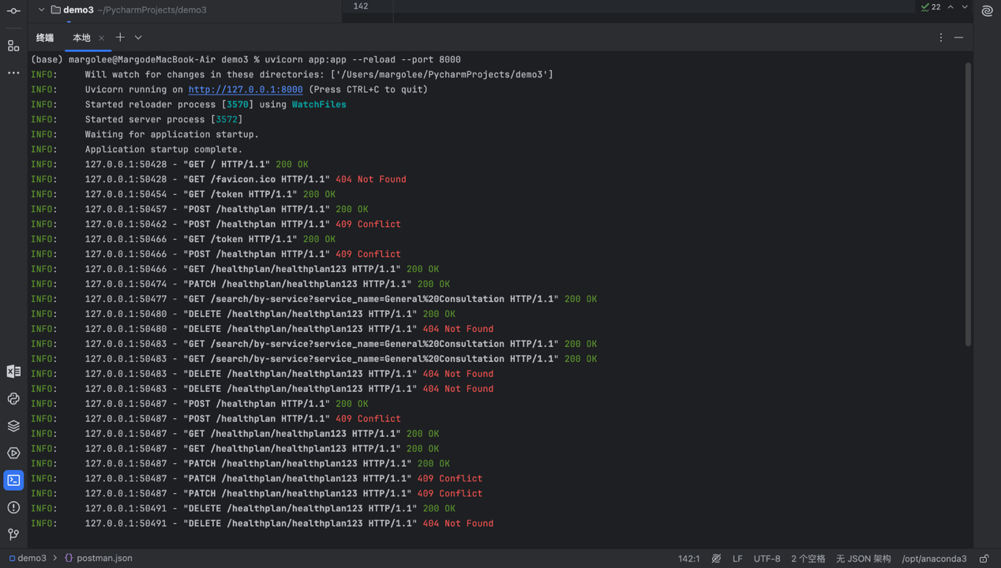

Demo3 Execution Log Summary
This is the execution log generated from running my FastAPI implementation of Demo3.
The log demonstrates all required REST behaviors:
✔ CRUD operations
✔ Deep merge PATCH
✔ Version control using If-Match (returns 409 on mismatch)
✔ Cascaded delete from KV store and index
✔ Parent-child indexing and search
✔ Queueing using FastAPI BackgroundTasks
✔ Security validation with Bearer token
✔ JSON Schema-based validation through Pydantic
Each endpoint was triggered in Postman, and the server responses validate the correct behavior.

